**Attendance System Using Face Recognition**

Project report in partial fulfillment of the requirement for the award of the degree of

Master of Computer Applications

Submitted By

|  |  |
| --- | --- |
| Nishi Paul  University Roll No. 12019007015036 | Department of Computer Applications  UEM, Kolkata |
| Sayandeep Sengupta  University Roll No. 12019007015049 | Department of Computer Applications  UEM, Kolkata |
| Kaustuv Kali  University Roll No. 12019007015004 | Department of Computer Applications  UEM, Kolkata |
| Biswadeep Nandi  University Roll No. 12019007015026 | Department of Computer Applications  UEM, Kolkata |

Under the guidance of

PROF. Biswadeb Bandopadhyay

Department of Computer Applications

UEM, Kolkata



UNIVERSITY OF ENGINEERING & MANAGEMENT, KOLKATA

University Area, Plot No. III – B/5, New Town, Action Area – III, Kolkata – 700 156

**CERTIFICATE**

This is to certify that the project entitled **Attendance System Using Face Recognition** submitted by Sayandeep Sengupta (University Roll No. 12019007015049), Kaustuv Kali (University Roll No. 12019007015004), Nishi Paul (University Roll No. 12019007015036), Biswadeep Nandi (University Roll No. 12019007015026), students of UNIVERSITY OF ENGINEERING & MANAGEMENT, KOLKATA, in fulfilment of requirement for the degree of Master of Computer Applications is a bona fide work carried out by them under the supervision and guidance of Prof. Biswadeb Bandopadhyay during 6th Semester of academic session of 2019-2022. The content of this report has not been submitted to any other university or institute for the award of any other degree.

I am glad to inform that the work is entirely original and its performance is found to be quite satisfactory.

_______________________________ _________________________________

Prof. Biswadeb Bandopadhyay Prof. Kaustuv Bhattacharjee

Assistant Professor Head of the Department

Department of Computer Applications Department of Computer Applications

UEM, Kolkata UEM, Kolkata

**ACKNOWLEDGEMENT**

We would like to take this opportunity to thank everyone whose cooperation and encouragement throughout the ongoing course of this project remains invaluable to us.

We are sincerely grateful to our guide Prof. Biswadeb Bandopadhyay of the Department of Computer Applications, UEM, Kolkata, for his wisdom, guidance and inspiration that helped us to go through with this project and take it to where it stands now.

We would also like to express our sincere gratitude to Prof. Kaustuv Bhattacharjee, HOD, Department of Computer Applications, UEM, Kolkata and all other departmental faculties for their ever-present assistant and encouragement.

Last but not the least, we would like to extend our warm regards to our families and peers who kept supporting us and always had faith in our work.

Nishi Paul

University Roll No. 12019007015036

Sayandeep Sengupta

University Roll No. 12019007015049

Kaustuv Kali

University Roll No. 12019007015004

Biswadeep Nandi

University Roll No. 12019007015026

**TABLE OF CONTENTS**

**ABSTRACT........................................................................ 5**

**CHAPTER – 1: INTRODUCTION............................................... 6**

**CHAPTER – 2: LITERATURE SURVEY**

**2.1 Research Methodology.............................................................. 7**

**CHAPTER – 3: PROBLEM STATEMENT & DISCUSSION**

**3.1 Problems ..................................................................... 8**

**3.2 Discussion ..................................................................... 8**

**CHAPTER – 4: PROPOSED SOLUTION & RESULT ANALYSIS**

**4.1 Solutions ..................................................................... 9 - 32**

**CHAPTER – 5: CONCLUSION & FUTURE SCOPE**

**5.1 Conclusion .................................................................... 33**

**5.2 Future Scope ................................................................. 33**

**CHAPTER – 6:**

**6.1 BIBLIOGRAPHY .................................. 34**

**6.2 REFERANCES ……………………….. 35**

**ABSTRACT**

One of the aims of this project is to make attendance and verification system easy for college and school students. This will help the medium, mainly the faculties, in taking attendance easily, at much lesser time than the old way. Besides, this may also help in fetching records, getting verification done and generating historical attendance reports with pictures of every student in a class from a single database. All these can happen in just a single click.

In this paper we propose an automated attendance management web app, with record keeping and verification of the student belonging to that class. This web app is based on face detection and face recognition algorithms, which will automatically detects students thereby recording their attendance with timestamp. Other aim of this project is to allow organisations go technical and paperless, thus reducing the efforts of teacher and increasing effective class hours. Teachers can log in to their system, turn on the camera and students just have to show their faces in front of the camera fitted on the tutors’ system. The system will record the attendance and store it on teacher’s database with every possible student details that the teacher would like to have for that specific class and period.

Our primary aim is to make Colleges, Universities and Institutions use this system. In this competitive and always changing technical environment, we developed our web app with the intention of a better and growing future. Corporates and several other commercial places uses kind of similar system, but we made this more user friendly at low a cost, without the need of installation of any new gadget.

**Introduction**

The project is constructed with the intention of making it easier for the teachers to record attendance of the students, both in colleges and schools, easily and faster. Teachers can also fetch historical information on attendance and several other information of the students just by clicking a picture of them on their own laptop.

We have devised a program in python; which will make use of the system webcam, on which the program will run, to capture the face of a person in front of it. If that person is having their data recorded in the teacher’s database for that class, then the program will search for the image captured of that person in the database. Attendance will be marked for the known faces and the program will show face not registered for the unknown or not registered students. Thus the first job will be to take the accurate details of the students and record it in the database. From then on, the teachers do not have to do anything. The system will record the attendance with timestamp automatically. If at any time any faculty intends to get a detailed report of a student (for example who is having low attendance) then the faculty can look at the report from the database (which was stored previously) just by using the students picture or by a single click on his/her name.

As we can see that the world is speeding in technology, so we tried to bring up some technicality in attendance system as well. With the intention of making life easier and better and improving the verifications in lesser time with cost effectiveness, we visualized this project and developed it.

**LITERATURE SURVEY**

Even in this high tech world, several institutions and organisations records attendance manually. This takes up a considerable amount of time in teachers calling out every individuals’ names, even of those who are not present, and the students responding back, for those who are present. An automated attendance system can save a lot of time of teachers, thereby utilizing more time in teaching.

This system of ours do not require installation of any new gadgets. The face recognition and the attendance recording can be done using teachers’ laptop’s webcam. The webcam will be operated using a program which will catch the image in the webcam. The image captured will be then used for matching with the pictures in the database record of students for that class. On matching, that students name will be returned along with the timestamp. All this is done using the face recognition libraries and properties.

Bank and many organisations use Eye and biometric scanning system to recognise people. But this product can be used from devises like Mobile and Laptops via an application or a website, thereby making it handy and widely usable. It will capture the face, time, date, location etc. very fast and accurately.

**Research methodology:**

A regular attendance supervision system is an essential tool for any institute and organisations. Before starting this project we analyse and researched thoroughly from many websites, also many journals and reviews from peoples. We came with this project where not only big but also small organisations and Institutions can make their attendance system futuristic and fast.

**PROBLEM STATEMENT & DISCUSSION**

We have often seen that corporates and several other organizations are using face recognition system as verification purposes. Moreover it is being used in the borders for security purposes. We thought about using the technology in the attendance procedures of educational organizations. This is done to save time and effort.

**PROPOSED SOLUTION & RESULT ANALYSIS**

Face detection is completely based on Viola jones algorithm. As compared to other algorithm it has great detection rate and found more efficient. This algorithm is very useful in real time face detection. It takes more time for training the dataset but as compared to KLT algorithm it has great accuracy. Accuracy is the more important parameter when we dealing with the face detection. Viola jones algorithm use 24 X 24 window for cropping the facial part which can be used to extract the features information by further process of image processing. Viola Jones algorithm uses following parameters for detection of faces.

- Haar features to extract features from input image.

- Identification and to familiarize new images, normally called as integral images by which features that are used in detection are estimate as fast as possible.

- By using Ada boost learning algorithm the easy and efficient classifier is made which can use to select very small set of features from large set of input features which are very different from other and can be used to detect difference between two faces easily.

- For ignoring non facial part the last process, which involves gathering all features in cascade manner.

Here is our approach to the making of this project -

1. Camera takes snapshot of students.
2. On this image some operation will be carried out.
3. This image compare with database images on the basis of different features.
4. If the image matches with database image, then further operation will be perform.
5. Attendance will be mark if image is matched.

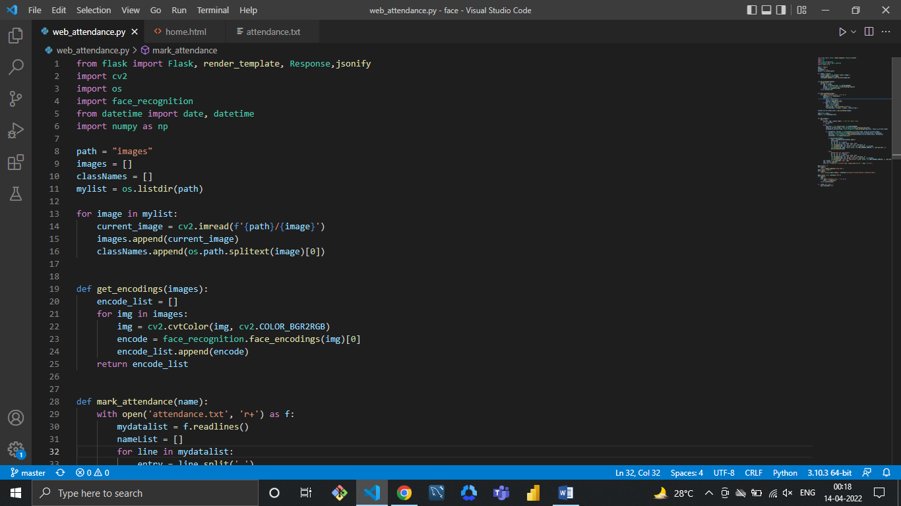

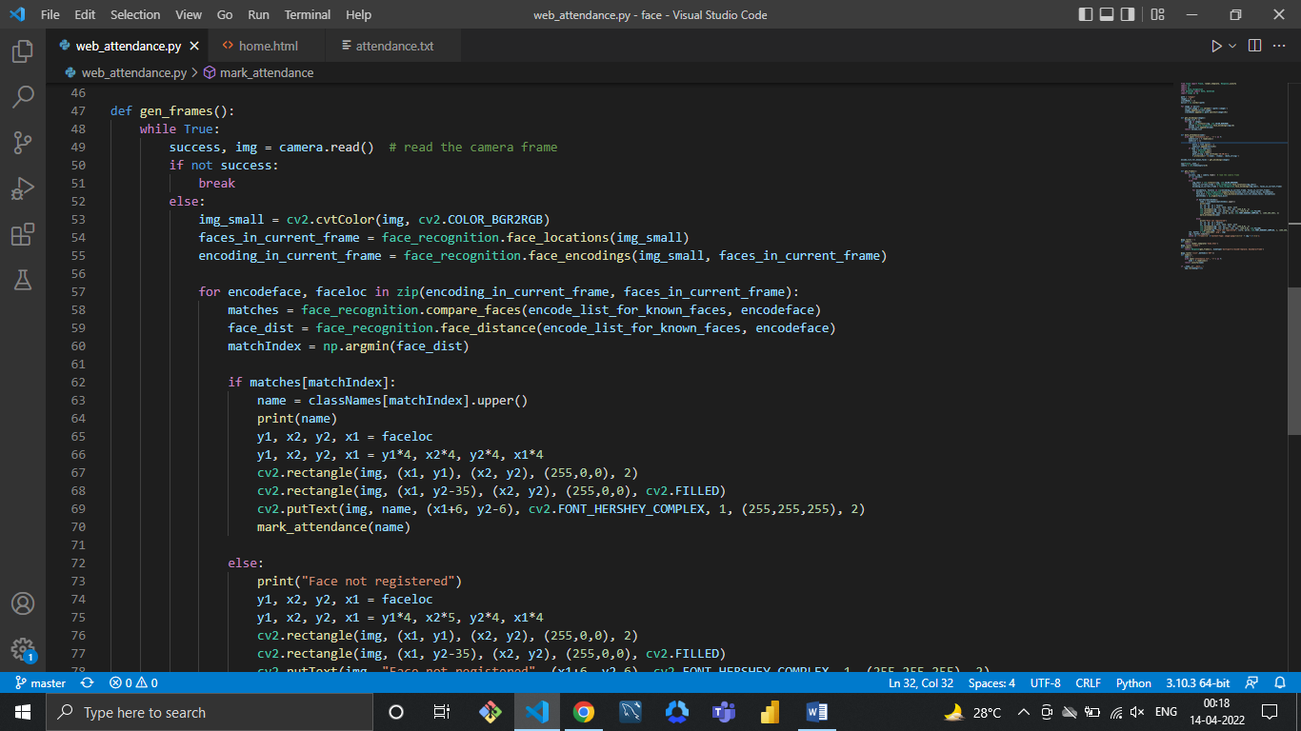

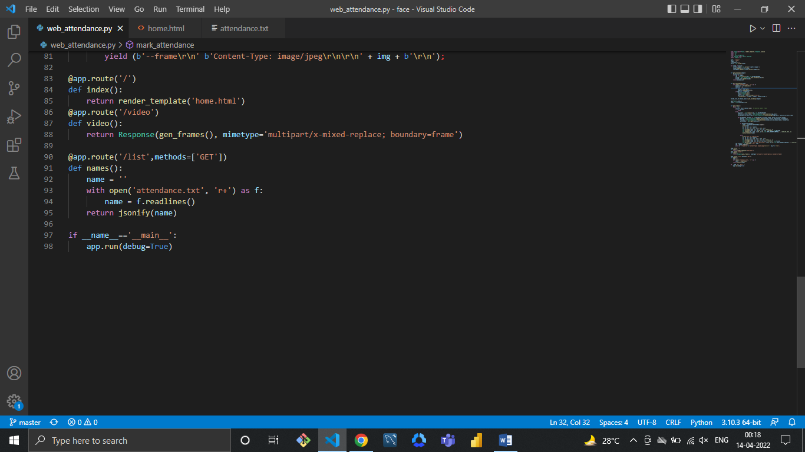

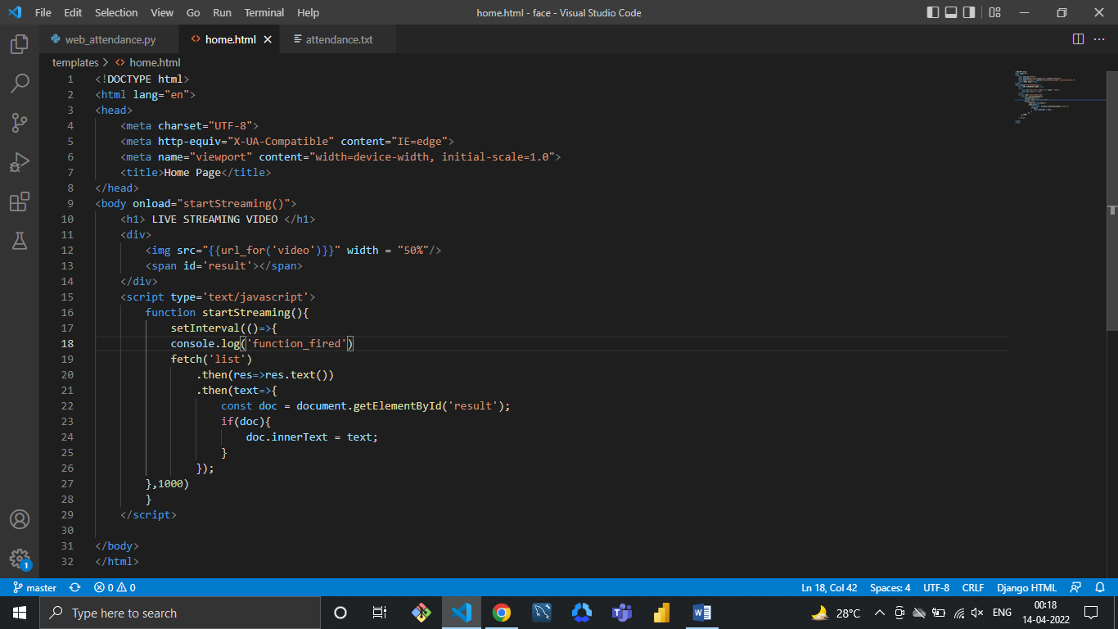

**CONCLUSION & FUTURE SCOPE**

Attendance is a necessary parameter which is required is most of schools and colleges. On an average this attendance is carried out to have accurate count of people or students seating in a particular classroom or any practice area. Traditional method of taking this attendance carried out by humans where the lecturer or teacher manually counts each and every student with their required data. Scanned image is processed and compared with preloaded image, as soon as image gets identified our algorithm indicated the master processor to transmit the identified person data to the database. system is a necessary tool for any learning management Institutions. Most of the existing systems are time consuming and require a semi manual work from the teacher or students. Our approach aims to solve the issues by integrating face recognition in the process.

**BIBLIOGRAPHY**

**REFERENCES**

1. <https://www.ijana.in/>
2. https://theijes.com/papers/
3. <http://www.ijics.com/gallery/>
4. **History of attendance system using technology**   
   Viola John’s Algorithm- <https://towardsdatascience.com/the-intuition-behind-facial-detection-the-viola-jones-algorithm-29d9106b6999>
5. https://www.researchgate.net/publication/325474606_A_Novel_Study_on_Face_Recognition_Algorithms_and_its_Challenges